Tool Guide – Traceroute

Introduction
Traceroute is an essential tool for diagnosing network connectivity issues and performing network reconnaissance, as it maps the path packets take from your host to another host.
Safety Disclaimer: Use only on networks and systems for which you have explicit authorisation. Unauthorized use of tools can be Illegal, unethical and harmful.

Setup and Launch
  - Step1: Open Deakin Detonator Toolkit
- Open Terminal in Linux
- Navigate to your Deakin Detonator Toolkit directory: (cd ~/Deakin-Detonator-Toolkit)
- Run DDT by using the following command line: (yarn run tauri dev)
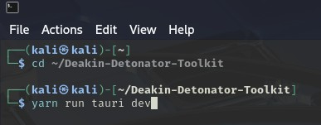
  - Step2: Find Tool-example
- Click on Tools to the left (or use the quick search bar)
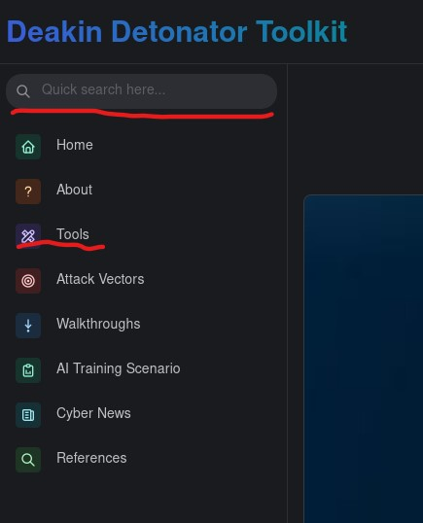
- If you clicked on Tools, scroll down and find Dig and click go

Configuration and Usage
  - Step3: Configuring Traceroute
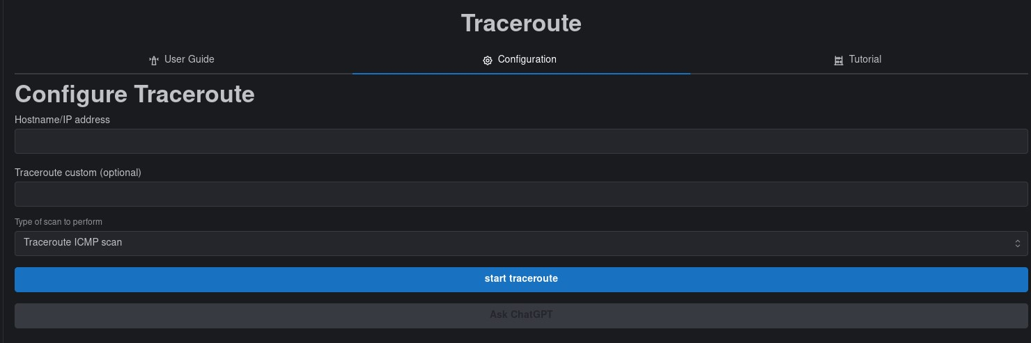
- Hostname/IP address: this fields sets the destination IP address
  - you can type either a domain name such as “example.com” or an IP address such as “8.8.8.8.”
- Traceroute custom (optional): you can customise traceroute with several commands, the list below is a set of examples (Courtesy of James Dunn)
  - "-m" Set the maximum number of hops to trace.
  - "-q" Sets the number of probe packets per hop.
  - "-w" Sets the wait time in seconds for each probe.
  - "-n" Tells Traceroute not to resolve hostnames.
  - "-f" Sets the starting hop number.
  - "-p" Sets the destination port for probes.
  - "-s" Specifies the source IP address to use.
  - "-4" or "-6" Forces the use of IPv4 or IPv6.
  - "-I" Use ICMP echo instead of the default UDP.
  - "-T" Use TCP SYN packets instead of the default UDP.
- Type of scan to perform: select the scan type you wish to use, the below are the available options
  - Traceroute ICMP scan
  - Traceroute TCP scan
  - Traceroute UDP scan
  - Traceroute custom scan

  - Step4: Results
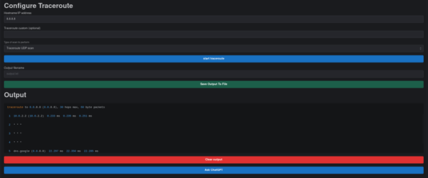
- You will be given an output that should end with “process completed successfully” and be sure to scroll up in the Output field to see the rest.
- Optional: You can save your output by filling out the new “Output filename” field with an appropriate name (output.txt) and then clicking “Save Output To File” button
- Optional: You can copy your output to your clipboard by clicking the little clipboard in the top-right of the output area.

Output Explanation
Note: your output will naturally be dependent on what domain/IP you checked and which options you selected, the following is non-comprehensive example output.

